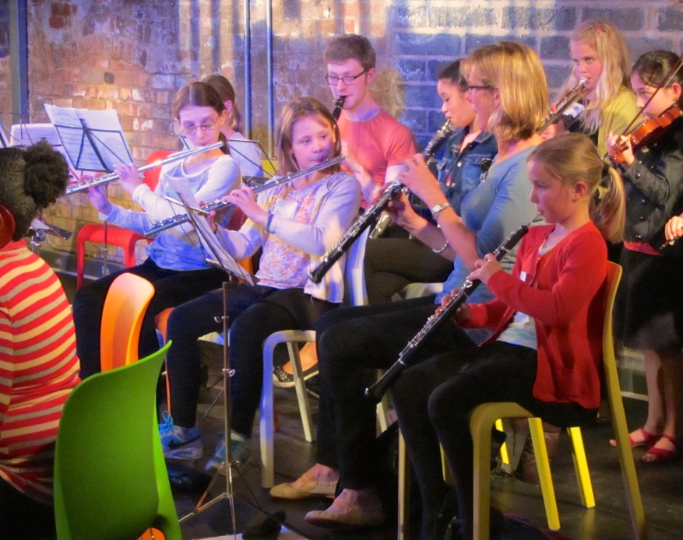
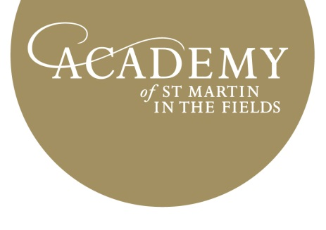
FREE ORCHESTRA PROJECT

FREE ORCHESTRA PROJECT
CREATE,CULTIVATE, ORCHESTRATE!

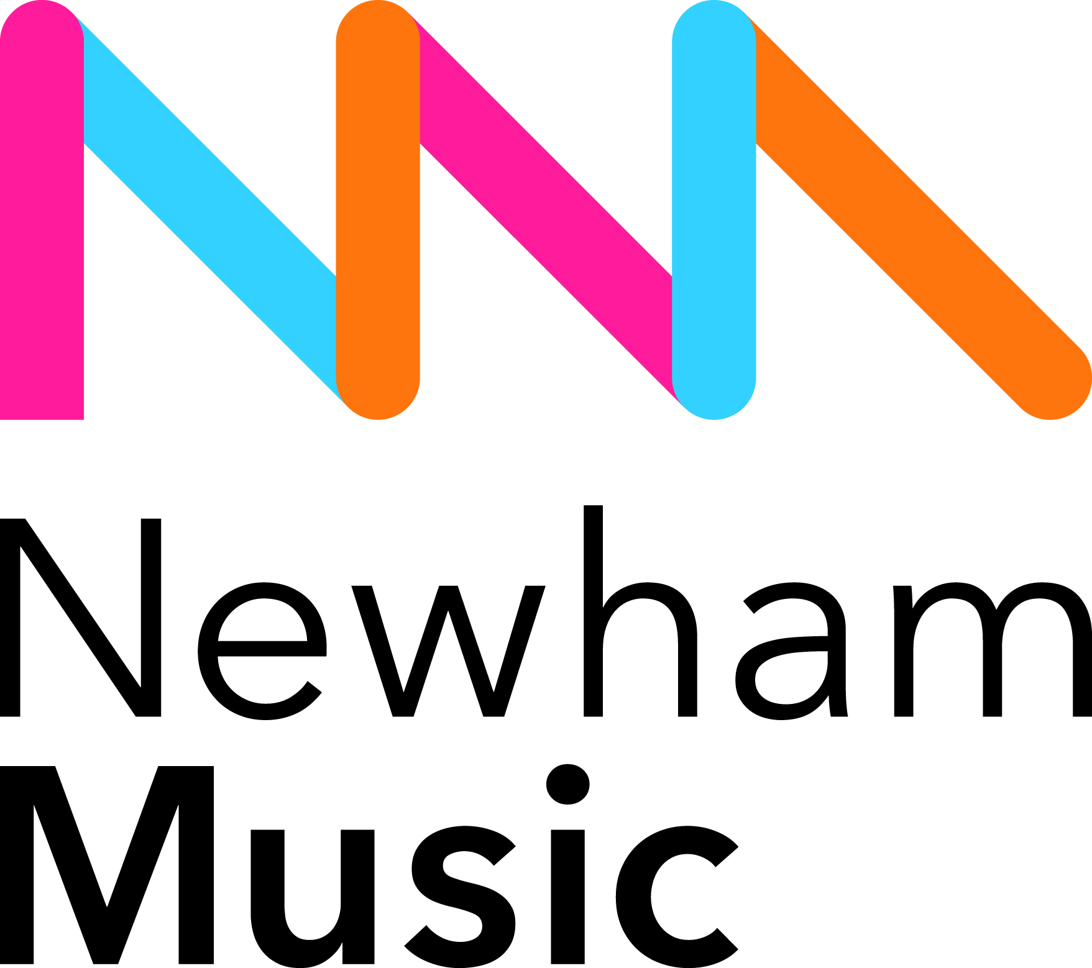
IMPROVISE, COMPOSE AND PERFORM
ALONGSIDE MUSICIANS FROM ONE OF THE WORLD’S FINEST ORCHESTRAS

Rehearsals at Chobham Academy, 40 Cheering Ln, Newham E20 1BD
WEDNESDAY 27th, THURSDAY 28th July
10.00-13.00 full ensemble, 14.00-17.00 advanced ensemble only

FRIDAY 29th July
13.00-14.00 advanced ensemble only, 14.30-16.00 full ensemble
PERFORMANCE AT CANARY WHARF
Summer Stage, Canada Park Square, Canary Wharf E14
17.00-17.45 SOUND CHECK
18.00-19.00 PERFORMANCE

There is also an opportunity to watch ASMF rehearse on Thursday 4th August between 2.30-5.30pm at the Amadeus Centre, 50 Shirland Rd, Little Venice, London W9 2JA

If you are aged 9-18 years and would like to book a free place complete and
return the form over the page.
With regret we cannot accept applications from students who play electronic/amplified instruments (e.g. electric guitar and keyboard) or piano. Applicants aged 13+ years and/or grade 3+ or equivalent on their instrument may be invited to join the advanced ensemble; places are limited.

w: www.asmf.org /asmforchestra @asmforchestrapage
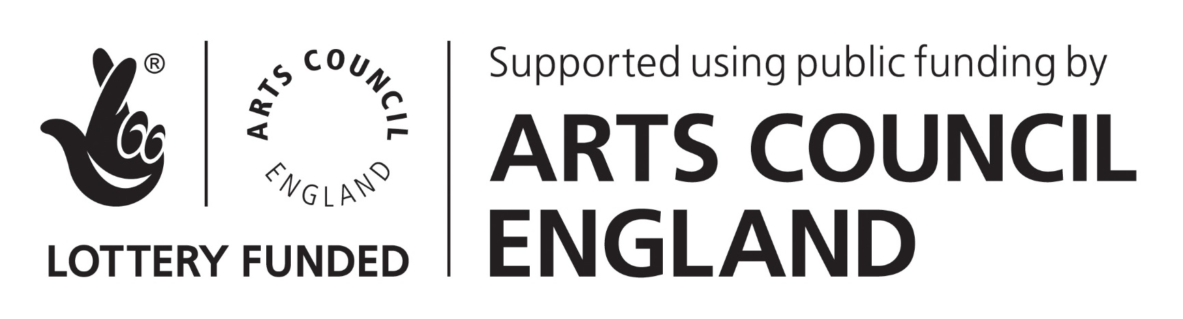

APPLICATION FORM
Student Name
D.O.B
NB if you are 13 years and grade 3+ you may be invited to join the advanced group
Instrument
Instrument grade (if no grade years learning)
Please state ‘yes’ or ‘no’ if you wish to attend the ASMF rehearsal
Parent/carer name
Contact number
Email
Home address
Emergency contact
(name and tel)
Do you have any special learning, medical, accessibility or other needs? Please specify

If your child is allowed to travel to and from the rehearsals and performance by themselves please circle YES below to confirm consent. Otherwise, all participants must be collected by an adult.
YES they can travel alone

By signing this form you are:
❐ giving consent for your child to take part in the project

❐ giving consent for your child to feature in any film or photography taken as part of the project.
With regret we cannot accept applications from participants who cannot feature in photos or film. Film and photography will be used for non-commercial, publicity purposes only.

❐ Confirming that your child has their own orchestral instrument that they will bring to the project to play.

APPLICATION FORM

For more information pick up an application form. To book your free place email your application to outwardsound@asmf.orgor post it to:
CREATE @ ASMF, 8 Baylis Road, London SE1 7AA

Signed: ……………………………………………………………………………………………………………………………………………………………………
Please send your completed application to charlotteodair@asmf.org or
Charlotte, O’Dair, ASMF, The Griffin Building, 83 Clerkenwell Road, London EC1R 5ARPlease be aware that project places are limited. Closing date for applications: Friday 8th July. The Academy will contact you to confirm your place.

