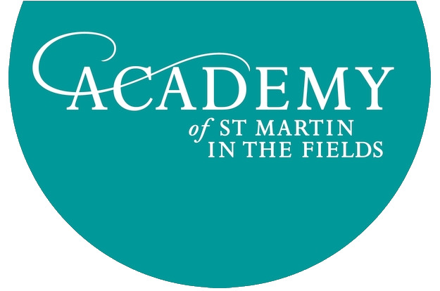

RECRUITMENT OF NEW CHIEF EXECUTIVE

Position Title: Chief Executive
Reporting To: Chair, Board of Trustees
Location: London, UK

The Academy of St Martin in the Fields (‘the Academy’) is one of the world’s leading chamber orchestras, with a strong international following and an excellent critical reputation built over the past 50 years. Founded in 1958 by Sir Neville Marriner, the Academy performs almost 100 concerts annually, including a high profile series of overseas concerts and a number of London and regional UK concerts.

The Academy has recently embarked on an exciting new phase of its evolution, including the appointment of Joshua Bell in May 2011 as the Academy’s Music Director. In addition, the orchestra has long-established artistic partnerships with some of the world’s leading musicians, including Sir Neville Marriner, the Academy’s Life President, and Principal Guest Conductor, Murray Perahia.

The Academy is seeking to appoint a new Chief Executive, accountable to the Board of Trustees, who will have overall responsibility for the leadership of the organisation. The Chief Executive will shape, plan and lead all principal activities of the Orchestra and work closely with the Music Director, the Academy’s artistic partners and the Board to develop the Academy’s artistic profile and activities.

The Academy operates with an annual expense budget of approximately £3 million. It meets that budget through a combination of fundraising, sponsorship, ticket sales and contracted income.

As the Academy approaches the end of six decades of thrilling audiences we have launched Sound Future - a three year, £2.5 million fundraising campaign in order to ensure that the Academy will continue to flourish both artistically and financially well into the future.

Leading the executive team of 13 from the Academy’s offices in Clerkenwell, the CEO will:

- Represent the Academy externally in all key artistic and business matters and with the players, membership, donors and funders;
- In conjunction with the Music Director, Head of Concerts and Touring and the players, drive long-term planning of the concert and touring schedule to ensure a full and artistically engaging schedule;
- Provide artistic leadership in collaboration with the Music Director and Head of Concerts and Touring;
- Promote the Academy through existing and new relationships with agents and promoters, both in the UK and overseas, to cultivate opportunities for performance, including with new audiences;
- Cultivate and maintain relationships with the Academy’s current touring partners, agents and promoters to further the artistic ambitions of the orchestra;
- Travel on orchestral tours as appropriate;
- In conjunction with the Board, Development Board and Director of Development, help lead fundraising and development activities to grow income streams from Individuals, Corporates and Trusts and Foundations, both in the UK and overseas;
- Lead a strategic planning initiative that will examine the long term health and direction of the Academy;
- Develop annual operating and financial plans that balance artistic ambition and sound financial management;
- Work closely with the Board to recruit and introduce new board members to the Academy and ensure current Trustees remain engaged;
- Maintain the Academy’s culture of collaboration among musicians, board, and staff;
- Oversee the hiring and management of the administrative staff through supervision of the department heads;
- Other duties as appropriate.

Relationships
- The CEO works collaboratively with the Music Director, both of whom report to the Board
- Important contacts include: Board of Trustees, Development Board members, Academy musicians, staff, donors, volunteers, agents, professional colleagues and community representatives.

Candidates for the position are expected to have:
- Previous experience in running an orchestra or an arts organisation in either a CEO or senior management position;
- Experience in marketing, development, business management and team leadership;
- Strong leadership and communication skills with the ability to represent the Academy in public and to potential donors and supporters;
- Proven track record of balancing artistic ambition with commercial reality;
- An understanding of the orchestral touring landscape;
- A track record of fundraising for an orchestra, arts or charitable organisation;
- A passion for and knowledge of classical music.

Compensation will be competitive, commensurate with the role.

Interested applicants should submit a CV with covering letter by Monday 5 September to the Academy’s Chairman, Paul Aylieff at chairman@asmf.org

Further information on the Academy can be found on our website www.asmf.org

