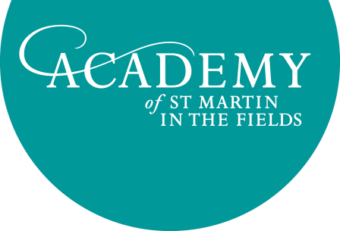

Job Title: Orchestral Administration Trainee
Reporting to: Concerts Manager
Salary: National minimum wage

The Academy of St Martin in the Fields is offering a six-month, full-time traineeship. The ideal candidate will have a passion for classical music, be musically literate, a clear desire to work in arts management and a keen interest in learning about the working of a busy touring orchestra.

The traineeship provides a rare opportunity to experience being part of a small, busy team and to develop new skills. You will learn about other arts organisations in the world of music, benefit from career advice from senior management, attend concerts and rehearsals and meet some of London’s finest classical musicians.

The successful applicant will be able to observe all areas of the organisation during the traineeship. As well as receiving training in office management skills, the busy Concerts and Education departments will provide opportunities to participate in projects such as:

Concerts
Assisting with concert/tour planning through helping with:
- Assisting with music library duties
- Assisting with the preparation of tour documentation such as Visas, A1s and Technical riders
- Preparing and distributing monthly schedules and project schedules
- Attending rehearsals and concerts in London and assisting with stage set up
- Compiling security lists for venues, comprising staff, orchestra personnel, artists and invited guests eg. friends and sponsors, school groups
- Assisting with artist logistics eg. hotel and car bookings
- Arranging instrument hire (e.g. keyboard instruments)
- Helping to maintain records
- General Office Administration

Learning and Participation
- Administration: drafting project documents including schedules, project descriptions, meeting papers, taking minutes for meetings
- Helping to administer organisational systems such as databases
- Partnership liaison: communications with community partners, members of the office and orchestra
- Planning: investigating, researching and helping to develop new opportunities
- Project assistance: attending Learning and Participation projects and performances to support staff and musicians, including assisting with registers, refreshments, event management and travel arrangements

Please note that you will be required to have a DBS check for any Learning and Participation work you do.

In order to be considered for this opportunity, please send your CV and a covering letter by email to Jo Harvey joannaharvey@asmf.org explaining why this traineeship interests you, why you would like to work for the Academy and what you feel you can bring to the role in line with the job description above.

