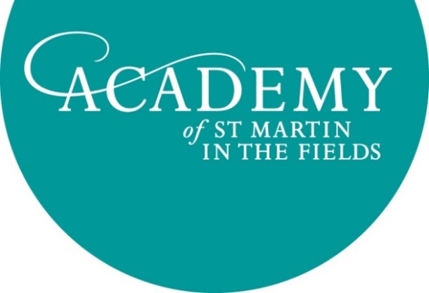
Job Title: Development Assistant
Location: London, UK

The Academy of St Martin in the Fields is one of the world’s leading chamber orchestras, with an enthusiasm for vibrant, fresh interpretations of orchestral music. Founded by Sir Neville Marriner, we are now led by virtuoso violinist Joshua Bell, performing around 100 concerts each year. The Academy aims to raise over £500,000 annually to support this busy international concert diary and a dynamic Learning & Participation programme of inspiring participatory music-making projects.

The Development Assistant role is a key part of the Development Team, working for the Chief Executive and Director of Development. This is an exciting opportunity for an individual keen to develop their career in the arts and arts fundraising to join a friendly and highly motivated team.

Key Responsibilities:
- To contribute to, and assist with the implementation of, the Academy’s fundraising strategy, engaging individuals, companies and Trusts & Foundations.
- To assist the Chief Executive to develop an International Advisory Board of Major Donors.
- To administrate the Academy Friends scheme.
- To assist with the delivery of large-scale, high-quality fundraising and cultivation events.
- To research opportunities and prepare applications to appropriate Trusts & Foundations.
- To collaborate with the Marketing & Communications Manager to deliver effective marketing and communications to support the fundraising strategy.
- To provide PA support to the Chief Executive and Director of Development.

Principal Duties include:
Donors
- Maintaining effective communications with current and prospective Academy Friends.
- Managing Friends’ membership renewals to a carefully prepared schedule, processing and acknowledging donations and ensuring timely delivery of relevant benefits.
- Operating a centralised ticketing system for Academy concerts, processing ticket sales for supporters and liaising with colleagues to allocate complimentary tickets.
- Assisting with logistics for fundraising events.
Trusts & Foundations
- Assisting the Director of Development to research, apply and report to funding bodies.
Marketing and Communications
- Coordinating and producing content & design for donor newsletters, in collaboration with the Marketing & Communications Manager.
- Maintaining up to date, accurate mailing lists.
PA Support
- Acting as the Chief Executive & Director of Development’s principal point of contact with all board members (main and International Advisory Board) and current/prospective donors.
- Arranging meetings and preparing meeting briefings as required.
- Preparing papers for board meetings and taking minutes at meetings.
General
- Preparing invoices and processing payments as required.
- Keeping abreast of GDPR and Fundraising Regulator developments.
- Keeping accurate records through the fundraising database Raiser’s Edge.
- Other duties as assigned by the Chief Executive and Director of Development.
Person Specification
- Educated to degree level or equivalent.
- One year’s experience working within the arts sector.
- Excellent verbal and written communication skills.
- Exceptional attention to detail and good organisation.
- Good IT skills, proficiency in MS Office programmes and experience in using CRM databases.
- Efficiency in online research.
The ideal candidate will…
- Be a bright, friendly personality who can communicate with genuine enthusiasm.
- Work confidently under the direction of the Director of Development.
- Be flexible, adaptable and enthusiastic.
- Be results-oriented, with a positive, hands-on, can-do approach.
- Have a strong work ethic; be able to work well in a team but with the capacity for setting their own goals and achieving them independently.
- Have an appreciation of and an enthusiasm for classical music.
- Have an outgoing, approachable and professional manner when dealing with donors.
- Be willing to attend Academy concerts and events out of office hours.

Benefits and terms
Salary £22,000 per annum, depending on experience.
25 days holiday per year plus public holidays.
Full time position with 8 weeks’ notice and an initial three month probationary period.
Enrolment in the Academy’s income protection plan.

Please apply with a CV and covering letter by email to susieyorkskinner@asmf.org

Closing Date for Applications: 20 December 2019
First round of interviews: 9 January 2020

